Lab Assignment 2-3 File System Management–File and Directory Permissions Linux+ and LPIC-1
- Login to Linux and issue the following four commands:
whoami
groups
touch file1
ls –l
And, show your results.
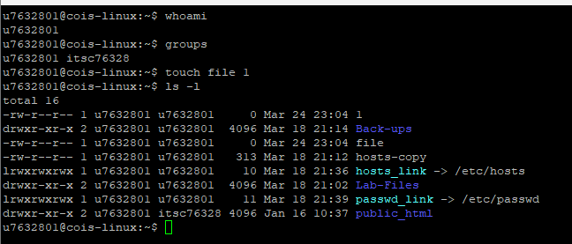

- Issue the commands:
chown root file1
chgrp sys file1
And, show the results.
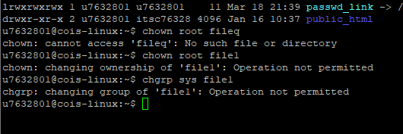

- Using vi or vim, create a file named script1 with the following lines:
pwd
ls –l
w
Then, issue the commands: “cat script1” and “ls –l”.
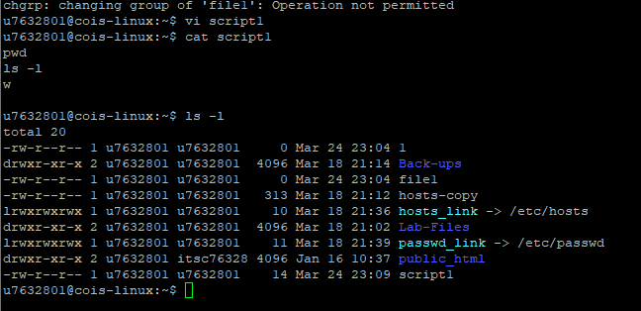

- Run the command to add execute permission to script1 for the file owner. Show the results.
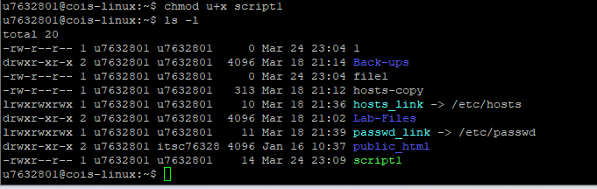

- Run script1 by entering is on the command line as: “./script1” Show the results.
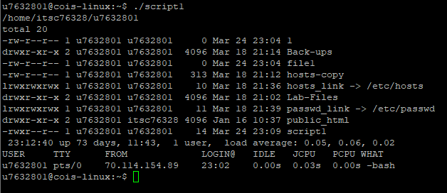

- Remove the write permission for group members and other users for samplescript. Show the command and the results.
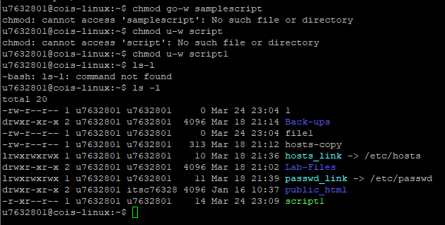

- Use touch to create file test1. Assign using numeric representation read, write, execute for the owner; and read and write for group members, and read for all other users. Show the command and the result.
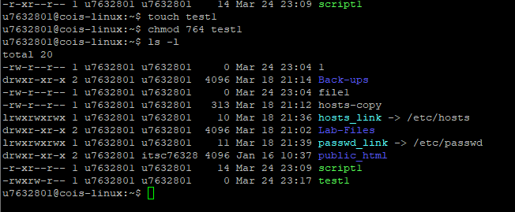

- Create a new file using touch named “fileX”; and a new directory using mkdir named “dirX”. Then run the command: ls –l.
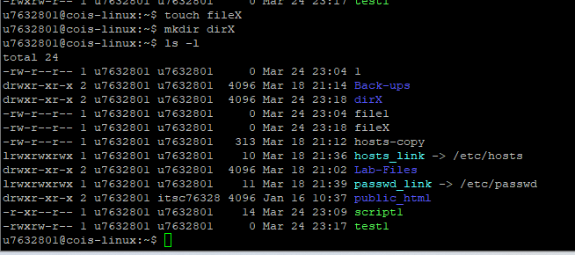

- Run the command “umask”. (umask provides the amount to subtract for each numeric permission; in this case 0000) Now run the umask command to change the umask value to 0044. Run umask without an argument.
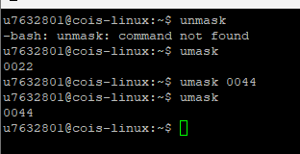

- Next, create a new file named fileY; and a new directory named dirY. Run the ls –l command. Note the differences between fileX and fileY; and the differences between dirX and dirY.
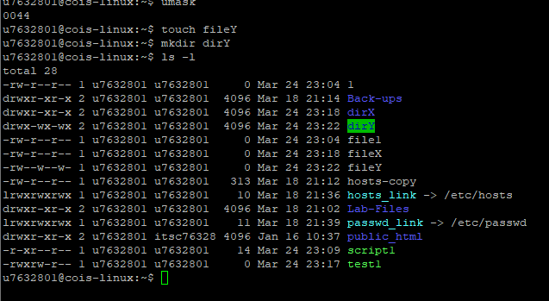
- Run the commands to remove directories dirX and dirY; then run the commands to removed files fileX and fileY. Run ls –l to verify.
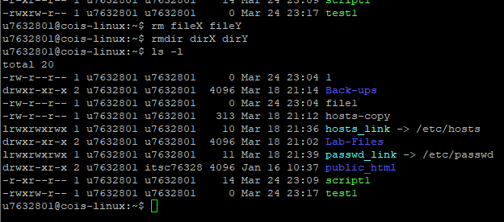

- Create a file named sFile; then create a directory named sDir. Run ls –l to verify.
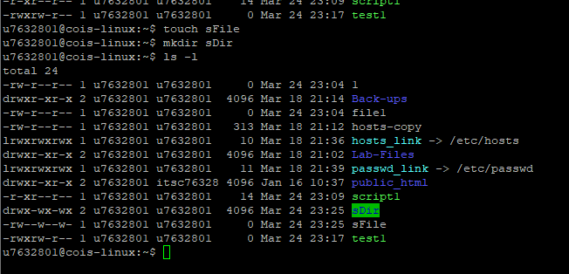

- Run the command: chmod 6755 sFile and show the results. (note the execute position for the file owner and group have changed)
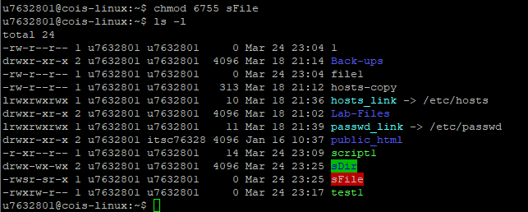
- Run the command: chmod 1777 sDir and show the results. (Note that the execute bit (position) for the owner, group, and other users have changed.)
